AVD Setup Guide ( BASIC SETUP with Entra ID)
Step 1: Create a Resource Group
Go to Home >Resource Groups >click on +Create
a) choose subscription for which you are creating AVD and Enter a Resource Group name
b) Select the Region for that Resource Group and Click Next tags .Leave tags as it is and then click Review and Create.
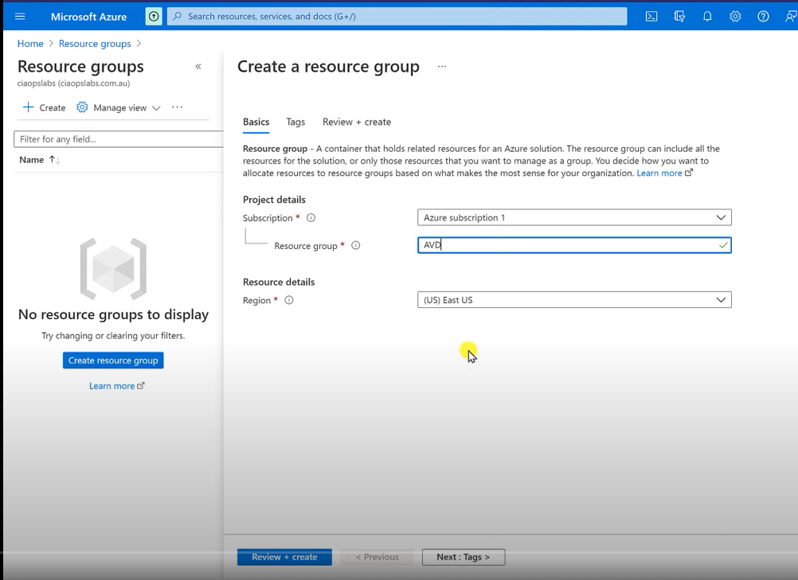 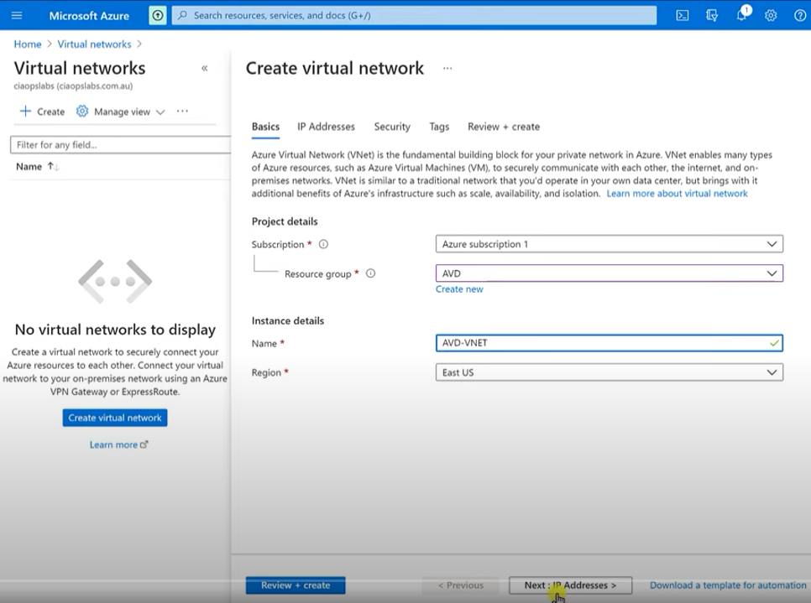
Step 2: Create Virtual Network.
a) Go to Azure blade left side and choose Virtual network options and click on create .
b) Choose subscription and newly created Resource group and provide new V-net name and Region in Instance details.
c) Click Next and Leave IP address page to default subnet >click next and Leave security options page as it is.
d) Leave tags and click Review and create .
Step 3- Create a Hostpool
- Search for Azure virtual desktop from the Azure search blade and choose Host-pools option from LHS side window.
- Click on create and new blade will open . Choose here Subscription for which we are creating AVD and Select Resource group as well.
- Provide Host-pool name and location (same as Vnet and Resource group) . Also select the type of Pool type
Personal will give 1 VM per 1 login and pooled will give multiple login on 1 VM. Choose the max session which we need to allow .
- Click next and it will ask to add virtual machines , let it be no to keep things simple. Click next and same thing for workspace (will ask to register desktop app group : Choose no) . Click next and in here do not enable diagnostic settings . Clcik next : again no tags >>Now finally review and create .
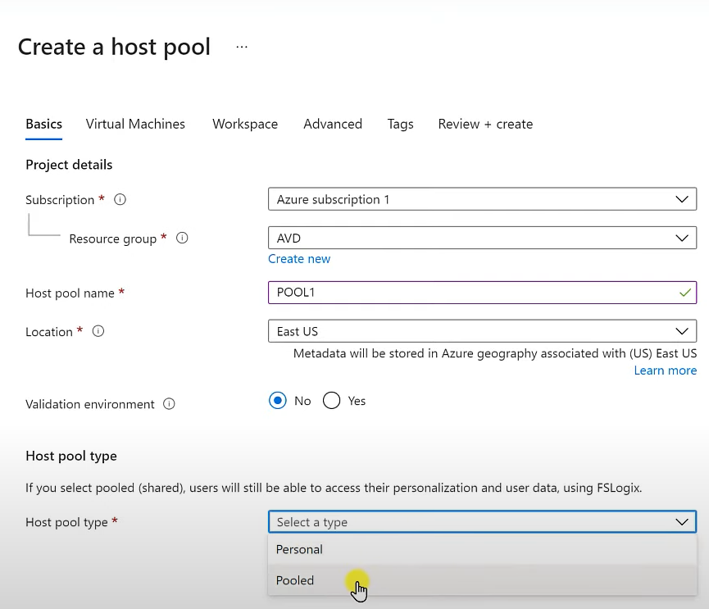 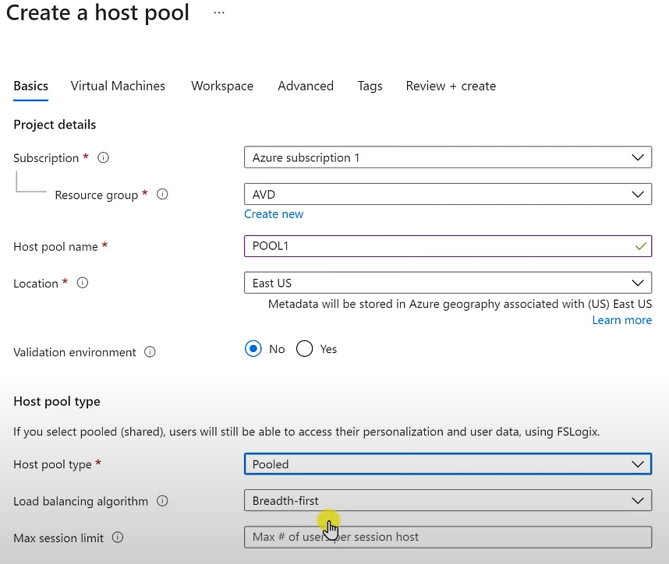
Step 4: Add virtual machines into pool :
a)Go to Azure virtual desktops > host pools > session hosts > click add.
b) New blade will open >>basics tab would be already filled >>now move to virtual machines tab>>give name for Virtual machine prefix (eg VM-1).
c) Choose the same location as for other resources >>choosing redundancy would increase cost
d) Chose no of VMs to create (1,2,3 etc)//change the size as per requirement .//choose the image for VM whether azure image or custom image(if you already have uploaded on azure storage).
e) Choose Virtal network //choose no for public inbound ports to not expose to outer network.
f) Choose directory >>Azure Active directory(authentication and managing done by Azure Directory) or Active directory(using in combination with AD connect)
g) Do not enroll VM with intune unless required// provide local administrator credential for VM
e) Simply now review and create >>no tags no advanced options .
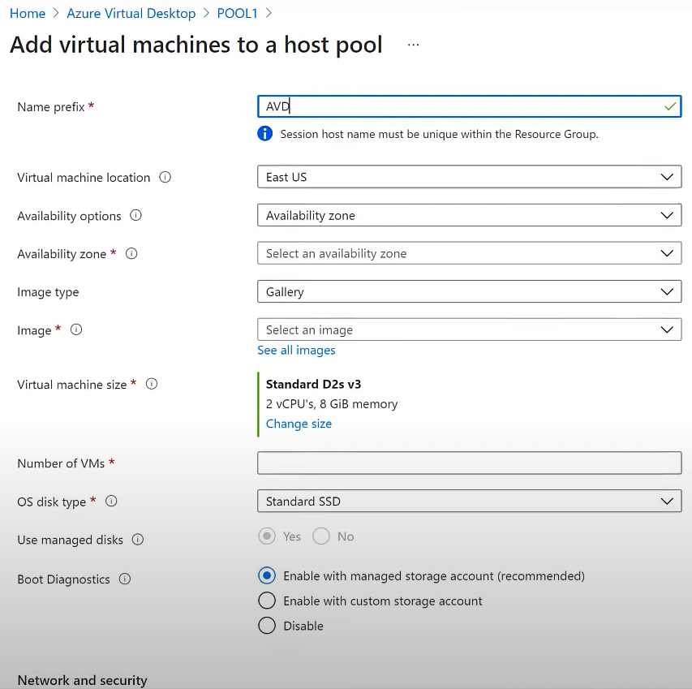 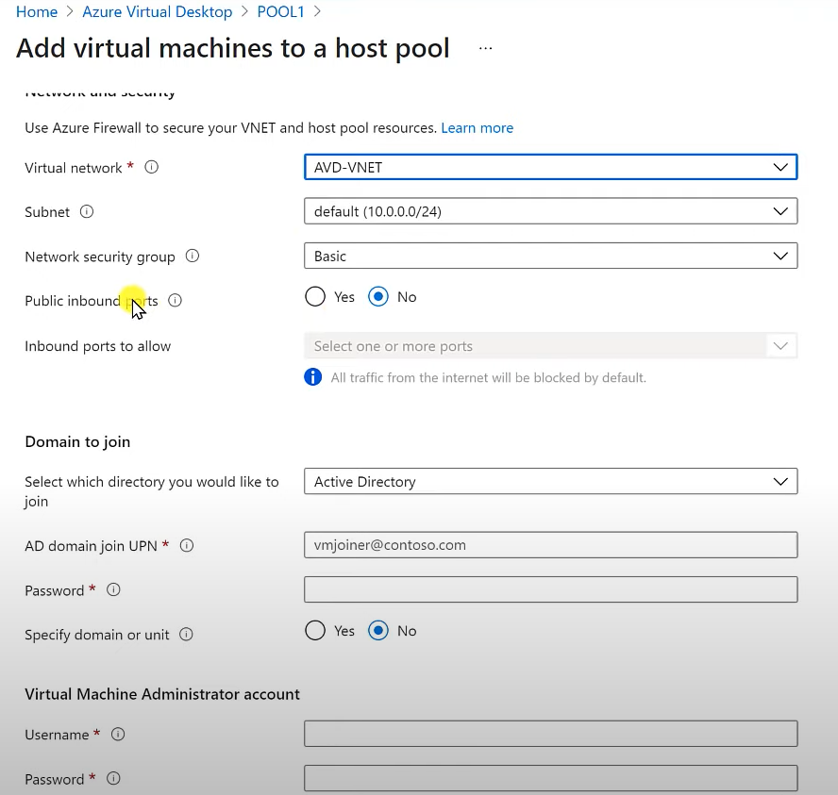

Step 5 : Add users to application group(DAG/RAG)
Now go to >Hostpool >Application group >Assignments :: Add here users required who needs to access the application group.
Now check if in Azure virtual desktop >hostpool >select application group from LHS you are able to see the Desfault DAG with 0 assignments and 1 application by default
Step 6 : Provide Virtual machine User Login role to users.
Go to Resource Group > Access Control(IAM) >Add role assignment>Virtual Machine user login or Virtual machine Administrator login.
Step 7: Create a Workspace
Go to Azure virtual desktop >Select Workspaces >Click Create
Here choose the correct Subscription and Resource group and provide a name to this workspace you are going to create with the correct location . Now simply review and create
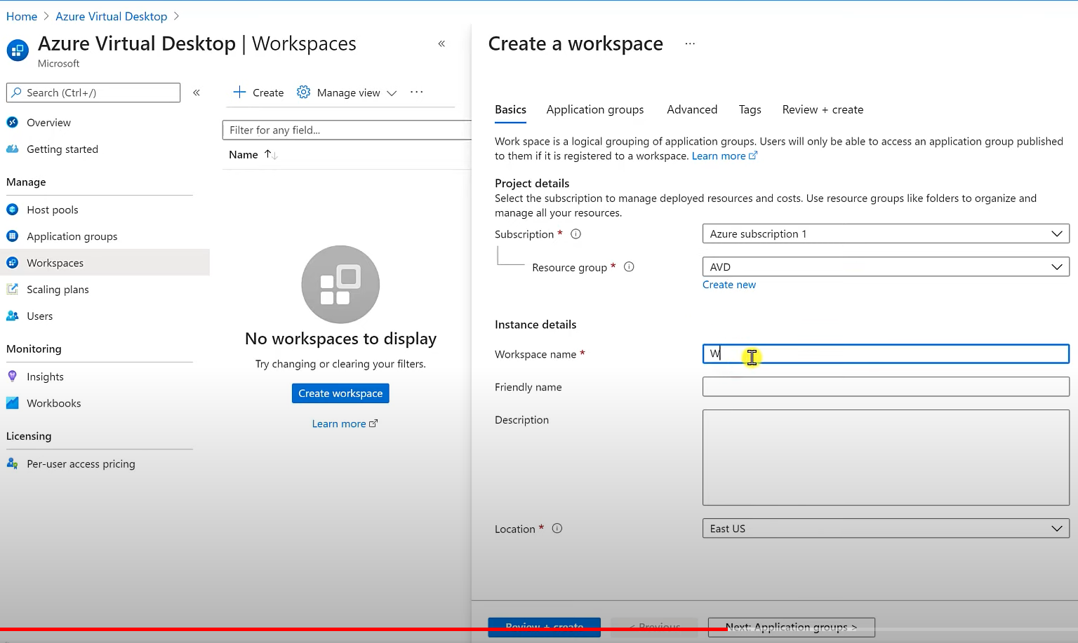 Step7 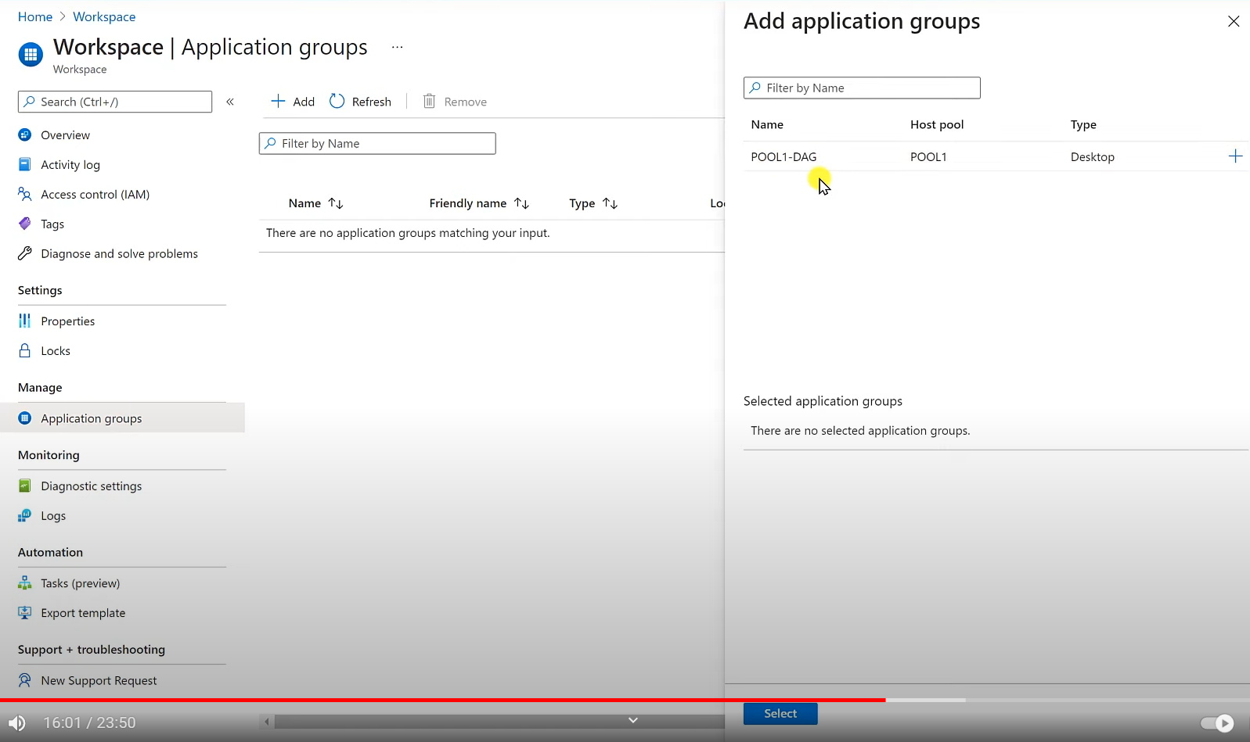Step 8
Step 8: Add the Application group to Newly created Workspace
Go to Workspace >Application Groups >Select the required Application group you want to add(+)
Note : you can have multiple workspaces for a user.
Step 9 : Add Advanced RDP property Targetisaadjoined:i:1 in Hostpools RDP properties.
Note : If this property is not added users accessing through unregistered Machines /web client/web browsers wont be able to login successfully.

AVD HYBRID SETUP (ADDS+EntraID)

Step :1 Create a stand alone VM hosting ADDS services on Windows server and then promote it as DC
- Create Standalone VM
  - Region should be same as the other machines hosted to reduce latency issues
  - Provide Local administrator account credentials for the Server
  - Public inbound ports must be opened like 443(HTTPS) , 80(HTTP), 22(SSH) and 3389(RDP)
  - Load balancing should be none
  - Public IP will be automatically assigned once deployment finishes
- Install ADDS and Promote as DC
  - Install ADDS on Windows Server in role based or feature based roles
  - Promote the server to domain controller once ADDS ins installed
  - Click >Add a new forest name and provide >Root domain name
  - Only enable DNS server and Global catalog Capabilities in checkbox
  - Provide password for Domain service restore mode(DSRM)
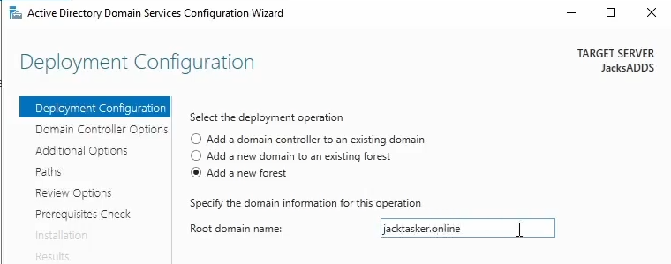

- Install AD connect (azure Ad connect V2)
  - Configure after ADDS setup is done only
  - Use Express settings
  - Enter Azure Global admin credentials (abhi@trainee5.onmicrosoft.com)
  - Enter ADDS Admin Credentials (Jacktasker.online\Abhi12)
  - Once configured it will start synchronization process.
- Configure VNET
  - Copy the private IP address of the DC VM and paste it in >VNET>DNS servers> select "custom " and paste here .
  - Also add Azure DNS IP : 168.63.129.16 as shown below
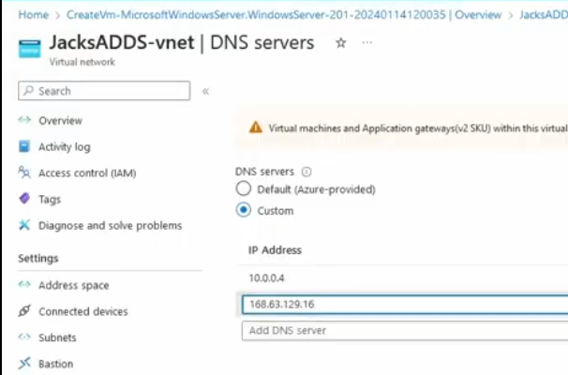

Step 2: Create a Fileshare and Configure ADDS identity based access
- Create fileshare in same VNET's storage account
  - Enable public access from all Networks for the fileshare.
  - Region should be same as other Resources
  - Disable soft delete features as it is not required for test environment
  - Choose hot or cold tier for Continuous or Casual use of storage
- Configure File share using ADDS Authentication
  - Download and unzip the latest version of the AzFilesHybrid module.
  - Once downloaded extract it and paste in nearest location like C drive or D drive . It containes 3 files out of which AzfilesHybrid.psd1 is main file.
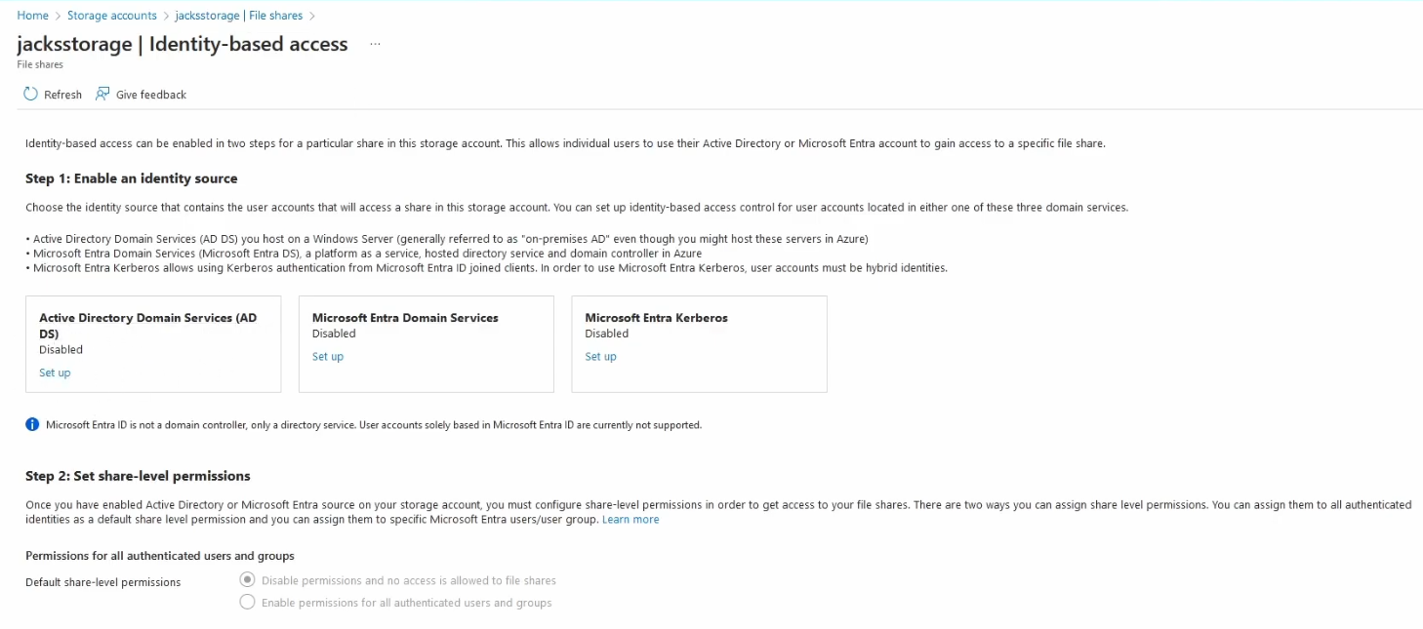
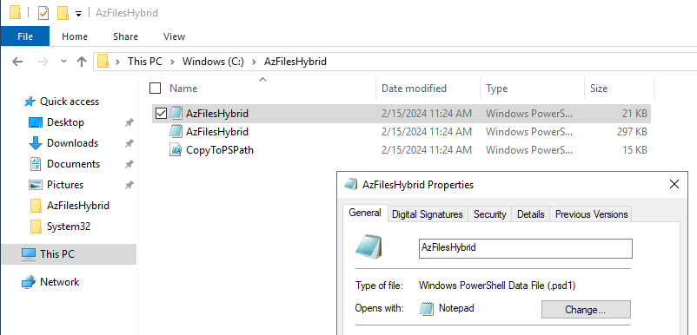
- Run the below commands in elevated powershell

>> Set-ExecutionPolicy -ExecutionPolicy Unrestricted -Scope CurrentUser
# Change the execution policy to unblock importing AzFilesHybrid.psm1 module

>> Import-Module -Name AzFilesHybrid
Or
>> Import-Module -Name AzFilesHybrid.psd1
# Navigate to where AzFilesHybrid is unzipped and stored and run to copy the files into your path
.\CopyToPSPath.ps1
# Import AzFilesHybrid module

>> Connect-AzAccount
# Login to Azure using a credential that has either storage account owner or contributor Azure role
Once done successfully till here , you would see the below message
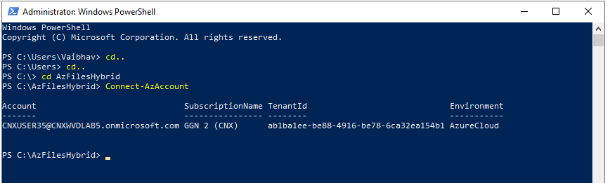

>> Join-AzStorageAccount `
-ResourceGroupName $ResourceGroupName `
-StorageAccountName $StorageAccountName `
-SamAccountName $SamAccountName `
-DomainAccountType $DomainAccountType `
-OrganizationalUnitDistinguishedName $OuDistinguishedName
# Register the target storage account with your active directory environment under the target OU

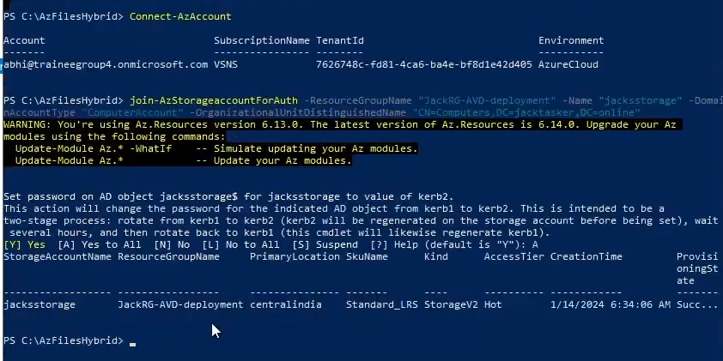

- Share kevel permission must be enabled and Role must be SMB Share Elevated contributor.

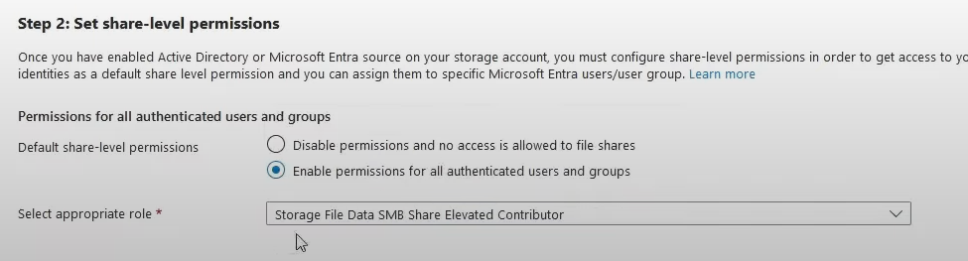

STEP 3. Create Hostpool with new workspace
* Note >> Whenever you create a host pool for hybrid AVD (onprem ADDS) , pre configure the DNS(important)

- Create a new Pool with ADDS Domain joined VMs
  - Provide AD to join VMs
  - Provide a UPN /user accoutn syned with Onprem AD
  - When successfully provided with credential and password it should show green check
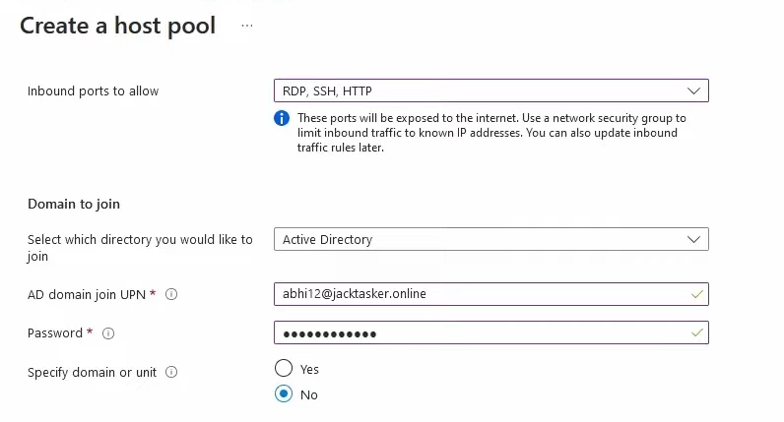

- Create a new Workspace and add users to DAG group
  - Goto Hostpool >> application groups >> Group(DAG) >> Assignments >> click Add select the OU/Security group to DAG /RAG of the Pool

STEP 4. Create a Security Group and provide NTFS and RBAC permissions

- Create a Security Group on Onprem DC(ADDS)
  - Goto Users and computer > users >right click users folder > New security group
  - Add more users from here in this group if required.
  - Make sure you assign these users/Security group as Inbuilt Remote desktop users >as shown below
  - Goto AD > Builtin folder> Remote desktop users and add the Security group here
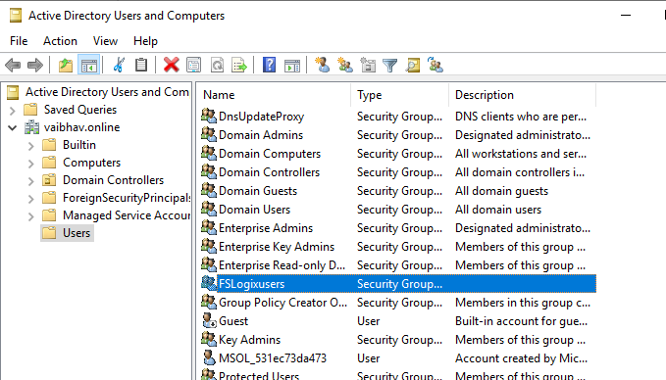
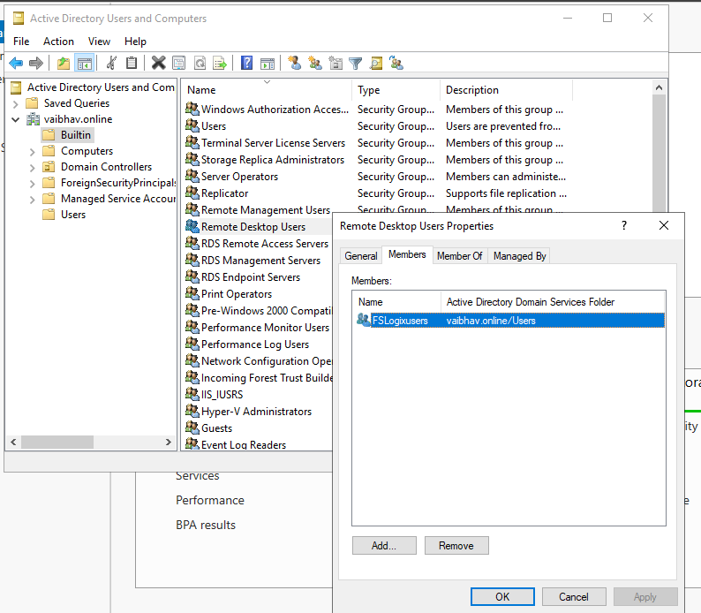

- Once the Users and groups sync up through AD connect we can see them here>as shown below
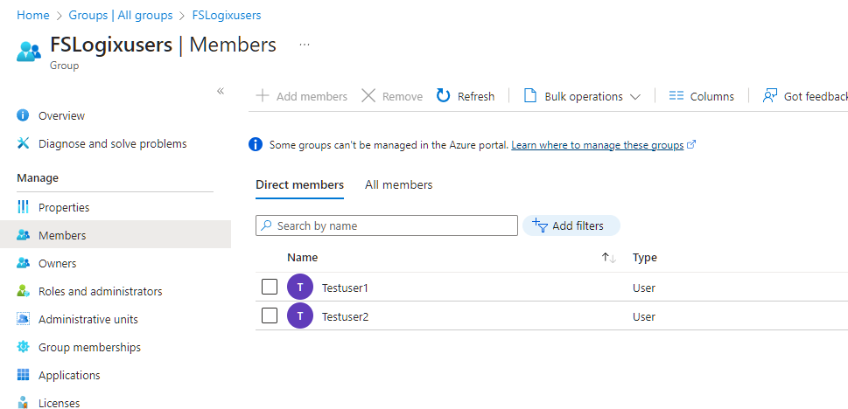

- Provide RBAC Roles to users/group
  - Add RBAC role "Virtual machine user login" from Resource group level (Resource Group >>Acces IAM) and add the OU/Security group to this role.
  - Add RBAC role "Storage File Data SMB Share Contributor" on Storage Account level (Storage Account >Access IAM)
  - The user/group should also must have "Desktop Virtualization User " role from Application Group level
  - Best way to check if users have all 3 required access is to check any user and check for Azure Role assignments
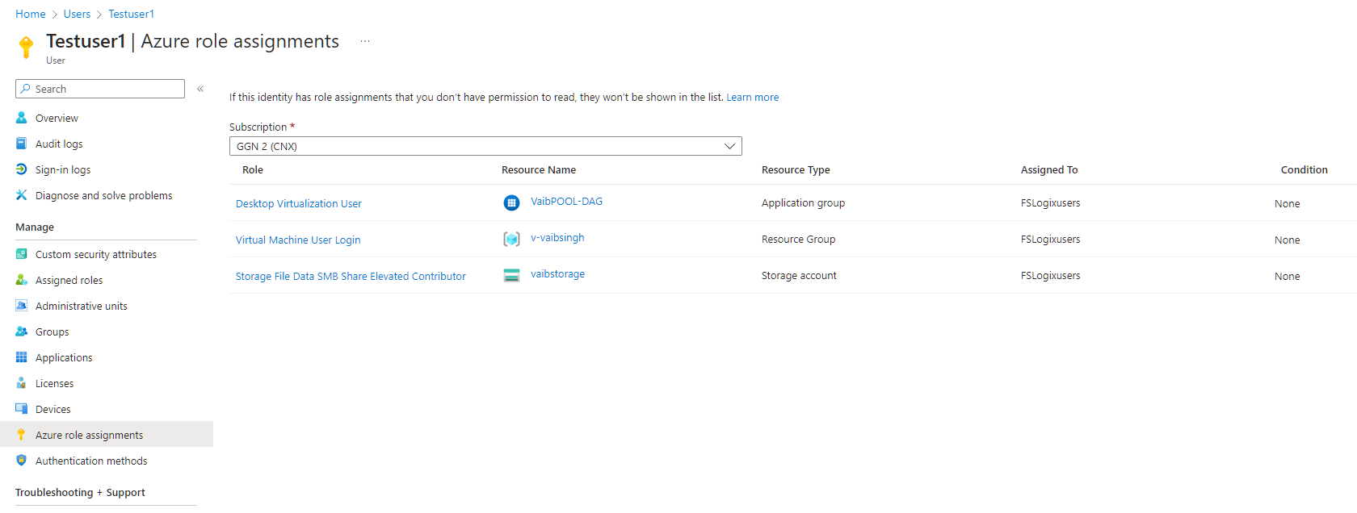

- Provide NTFS permissions to users/group
- Sign in to a session host that is part of your host pool.Open an elevated PowerShell prompt and run the command below to map the storage account as a drive on your session host. The mapped drive will not show in File Explorer, but can be viewed with the net use command. This is so you can set permissions on the share.
netuse <desired-drive-letter>: \\<storage-account-name>.file.core.windows.net\<share-name> <storage-account-key> /user:Azure\<storage-account-name>
Replace <desired-drive-letter> with a drive letter of your choice (for example, y:).
Replace all instances of <storage-account-name> with the name of the storage account you specified earlier.
Replace <share-name> with the name of the share you created earlier.
Replace <storage-account-key> with the storage account key from Azure

- Run the following commands to set permissions on the share that allow your Azure Virtual Desktop users to create their own profile while blocking access to the profiles of other users. You should use an Active Directory security group that contains the users you want to use Profile Container.
icacls <mounted-drive-letter>: /grant "<DOMAIN\GroupName>:(M)"
icacls <mounted-drive-letter>: /grant "Creator Owner:(OI)(CI)(IO)(M)"
icacls <mounted-drive-letter>: /remove "Authenticated Users"
icacls <mounted-drive-letter>: /remove "Builtin\Users"
SAMPLE
icacls y: /grant "CONTOSO\AVDUsers:(M)"
icacls y: /grant "Creator Owner:(OI)(CI)(IO)(M)"
icacls y: /remove "Authenticated Users"
icacls y: /remove "Builtin\Users"

Once done successfully you will see as below"The command completed successfully"
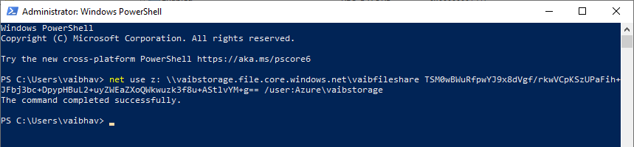

Step 5. Configure session hosts to use Profile Container

a. Either we can login into each VM with Local admin and run the below command to create registries
$regPath = "HKLM:\SOFTWARE\FSLogix\profiles"
New-ItemProperty -Path $regPath -Name Enabled -PropertyType DWORD -Value 1 -Force
New-ItemProperty -Path $regPath -Name VHDLocations -PropertyType MultiString -Value \\<storage-account-name>.file.core.windows.net\<share-name> -Force

b. Or we can Configure Standard registry keys in one session host and export to other session hosts by copying and pasting the reg file.

